Gluing the top 2 sections together
- Put Mousing lines in the mast. Wax the mousing lines prior to putting them in. This is vital so you don’t glue them to the inside of the mast. Do this by taping tightly a thin line (2mm) to your halyards and pulling through until your halyards are out of the mast.
- Separate the top 2 sections.
- Rub down the spigot from the top section with sand paper, and the same to the inside of the middle section. We used this to make sure you get the inside surface all the way down.
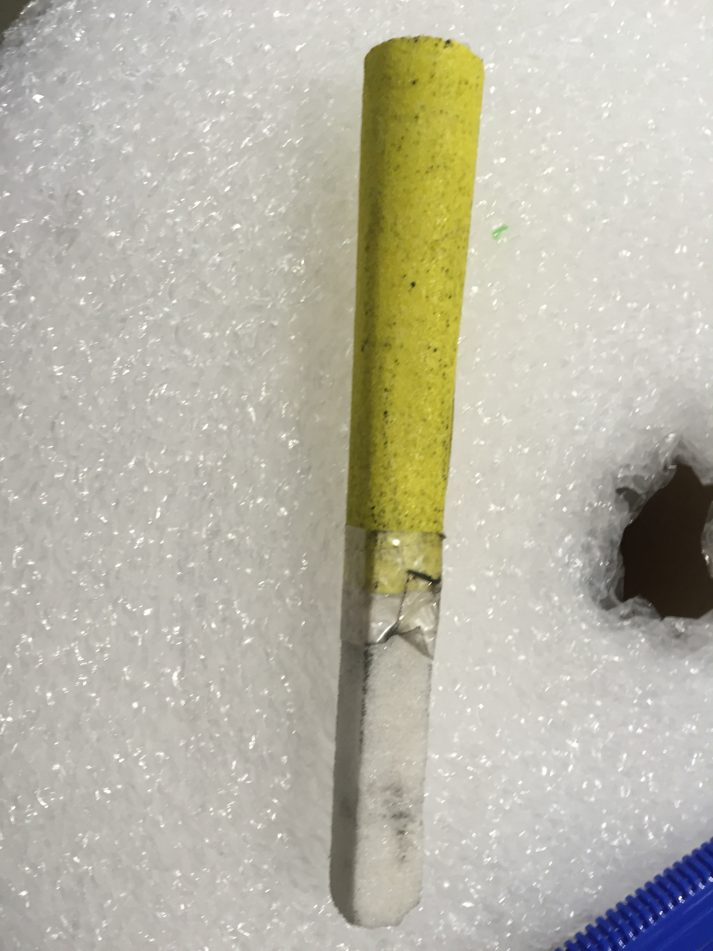
- Once the surfaces are prepped, rub down with Meths to remove the carbon dust and grease. Do this on the spigot and on the inside of the middle tube. Put a rag on a stick with meths to make sure you clean at least the length of the spigot.
- Mix your epoxy thoroughly. We used Spar Bond.
- Apply to the spigot and the inside of the middle tube. Use a long stick to apply to the inside of the middle tube.
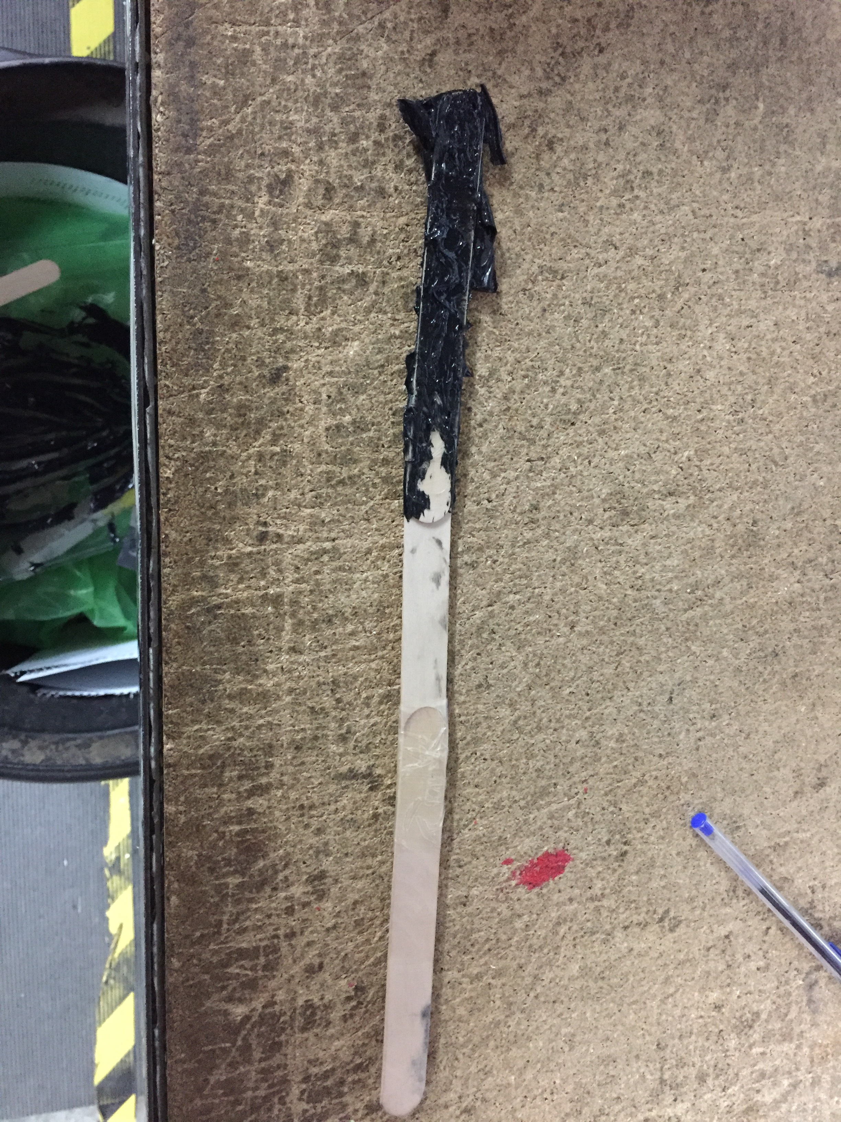
- Now slide both sections together. Ask someone to take up the slack in the mousing lines so that they don’t get jammed between the sections. Before pushing both sections fully together scrape off the large amount of epoxy that will gather up due to pushing the sections together. This will mean you won’t have to clean so much epoxy off the join and the mast track when fully done.
- Push both sections together fully.
- Clean the mast track joint with meths. You don’t want a lump of dry epoxy stopping you putting your main sail up.
- Find something exactly the width of the track so lot in to make sure the track is aligned while drying.
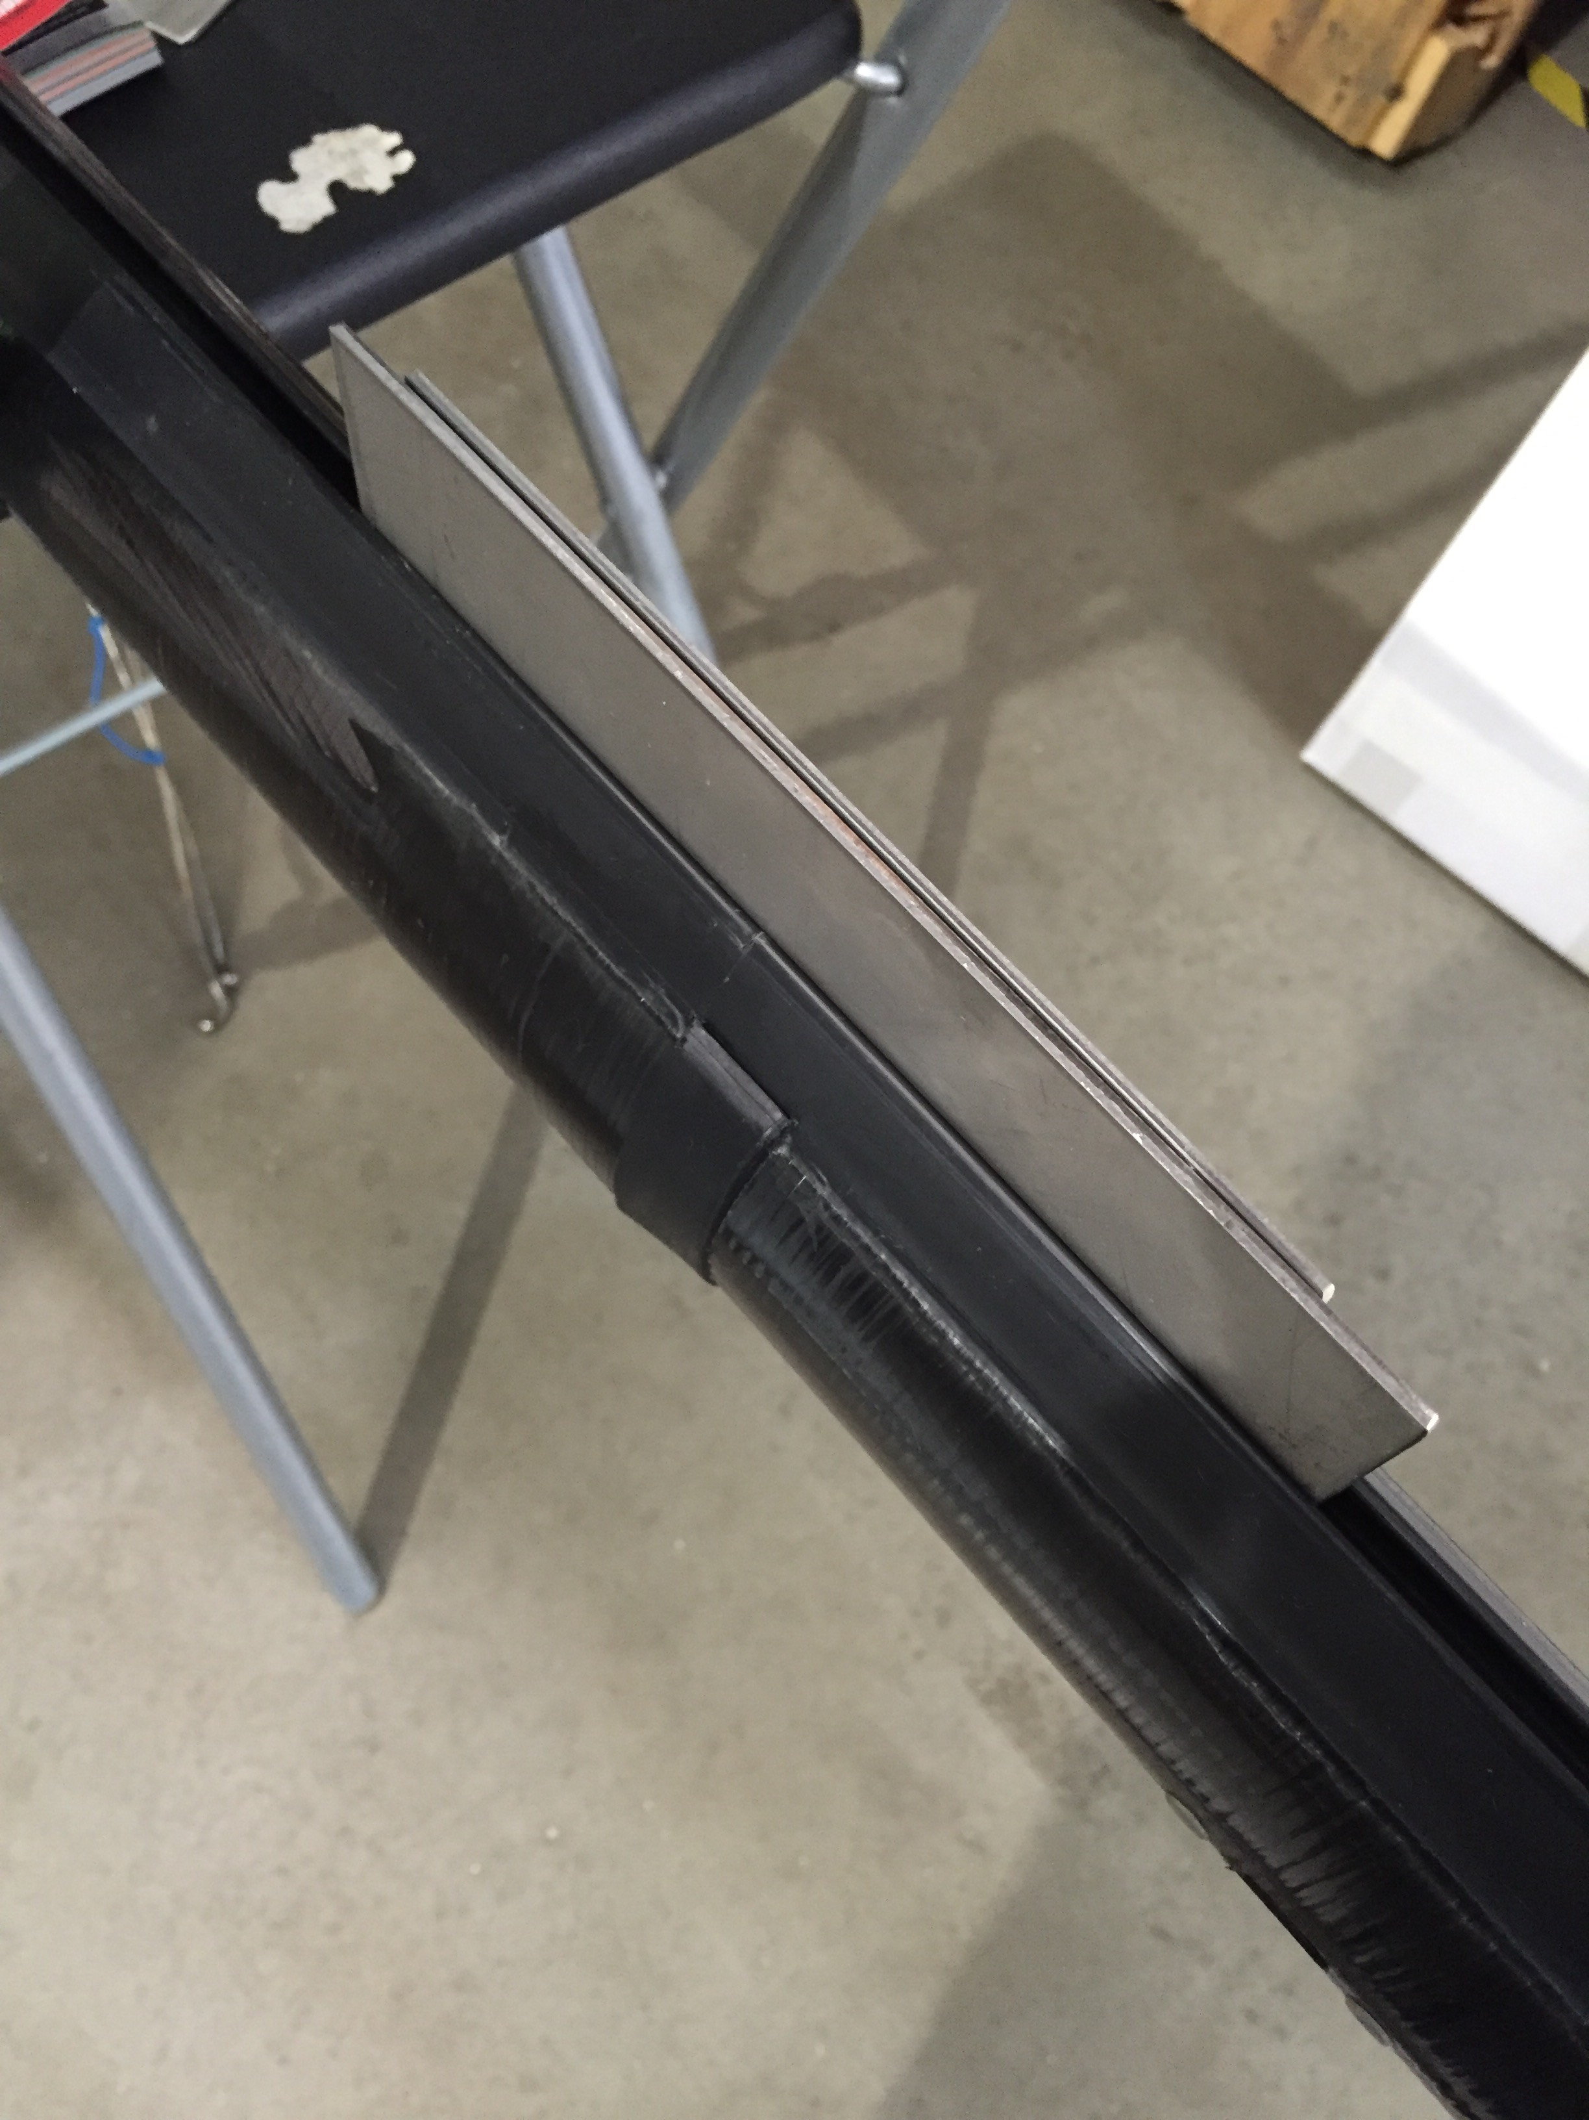
- Once dry, re tape your halyards to the mousing lines and pull through.

