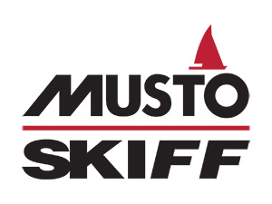
MUSTO Skiff Class Association

Event Coaching Application – GBR Class

Name of host club: …………………………………………………..

Date of coaching event: …………………………………………………..

Name of event organiser: …………………………………………………..

Name of coach: …………………………………………………..

Contact number of coach: …………………………………………………..

E-mail address of coach: …………………………………………………..

Minimum number of participants: …………………………………………

Maximum number of participants: …………………………………………

The GBR class association holds funds to help subsidise national coaching. These funds come from the class membership. Please ensure all participants are paid up members of the GBR class association. In the case where a sailor is not a member (for instance, a one-off visitor) please ensure they pay the full amount without class association subsidy.

Please note that all class coaching events must be run by an RYA qualified coach.

The coach must hold adequate insurance.

Ahead of any training session taking place, please complete and return this form to the class secretary at the email address secretary@mustoskiff.com for approval by the UK class committee.

MUSTO Skiff Class Association
Class Secretary: David Rickard
Email: secretary@mustoskiff.com
Website: www.mustoskiff.com

